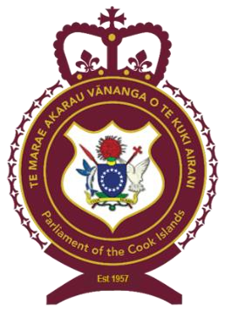
CONSTITUTIONAL REVIEW SPECIAL SELECT COMMITTEE

PUBLIC NOTICE

REVIEW OF THE CONSTITUTION AMENDMENT BILLS 30, 31 & 32, 2023
The Constitutional Review Special Select Committee invites expressions of interest from any person or organisations wishing to make a submission to the Committee on the Constitution Amendment Bills 30, 31 & 32, 2023.

Interested parties may contact the Committee Secretary, Mrs Margret Numanga on email – margret.numanga@cookislands.gov.ck or on telephone 26500 to submit their submissions or arrange an appointment with the Committee.

Copies of the Bills can be downloaded from the Parliament of the Cook Islands website - https://parliament.gov.ck

Closing date for expressions of interest and submissions is Wednesday 31st January 2024, at 4.00 p.m.

KUMITI ĀKARAKARA’ANGA MATATIO NO TE TURE METUA

TUATUA AKAKITE

ĀKARAKARA’ANGA MATATIO I TE TURE TAMANAKO AKATUKE’ANGA PAPA TURE METUA 30, 31 & 32, 2023
Te anoano nei te Kumiti Ākarakara’anga Matatio no te Ture Metua i te pati atu ki tetai uatu tangata me kāre putuputuanga tei anoano i te tuku manako ki runga i te Ture Tamanako Akatuke’anga Papa Ture Metua 30, 31 & 32, 2023.

Ko tei inangaro i te tuku manako mai ki runga i teia Ture Tamanako, taniuniu mai ki te Tekeretere o te Kumiti, ia Margret Numanga i runga i te imere margret.numanga@cookislands.gov.ck me kāre, ringi mai ki te numero 26500 no te tuku anga mai i toou manako me kāre no te akano’o anga i tetai tuatau no te aravei anga atu i te Kumiti.

Me ka inangaro koe i tetai kapikapi pēpa naau no te au Ture Tamanako, ka rauka te reira i runga i te kupe aorangi a te Marae Akarau Vānanga o te Kuki Airani – https://parliament.gov.ck

Ka piri teia tuku’anga manako ki te Kumiti i te Ruitoru rā 31 no Tianuare mataiti 2024 i te ‘ora 4 i te aiai.

